

Marketing Department jay.chalmers@franklinprimary.org 251.436.7791 ext. 7791

Franklin Primary Health Center Welcomes Pediatrician Dr. Chiquitia Anderson to the Franklin Medical Mall
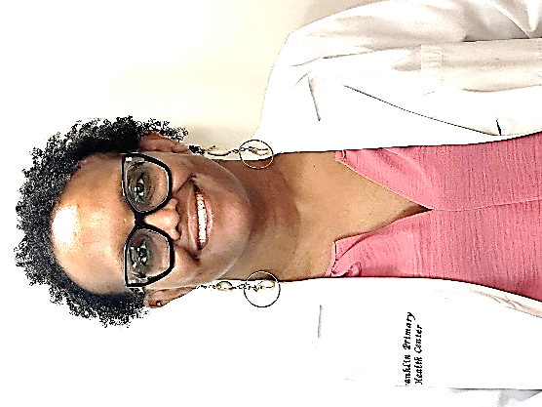
Mobile, Alabama – Franklin Primary Health Center (FPHC) is proud to announce the addition of Pediatric Physician Dr. Chiquitia Anderson, MD, to its team at the Franklin Medical Mall. Dr. Anderson’s arrival reflects Franklin’s continued commitment to expanding access to care for children.
Dr. Anderson is a board-certified pediatrician with more than 16 years of experience providing care across the full spectrum of childhood and adolescent health.
Throughout her career, Dr. Anderson has focused on building strong relationships with children and their families. She has demonstrated success in developing long-term, patient-centered medical homes and collaborating with multidisciplinary teams to improve health outcomes and promote long-term wellness. She is also committed to teaching future physicians and will work with students in Franklin’s Family Practice Residency Program.
Dr. Anderson earned her Doctor of Medicine from the University of Iowa Carver College of Medicine and completed her residency at Children’s Hospital of Michigan, where she served as Chief Pediatric Resident.
“Dr. Anderson will positively impact Franklin Primary and the communities we serve in many ways,” said Charles White, CEO of Frankin Primary Health Center, Inc. “Her experience providing quality care for her patients, combined with developing other patient-centered medical homes, and a commitment to our new Family Practice Residency Program demonstrate how she can make a difference, and we’re proud to have her.”
“I am excited to join the health care team at Franklin Primary Health Center,” said Dr. Anderson. “I look forward to partnering with the families of Mobile to help build strong foundations of physical and mental well-being, empowering children to grow into healthy, successful and prosperous individuals.”
The Franklin Medical Mall is open Monday through Saturday from 8:00 a.m. to 5:00 p.m. To schedule an appointment or learn more about services, please call (251) 432-4117 or visit franklinprimary.org.

